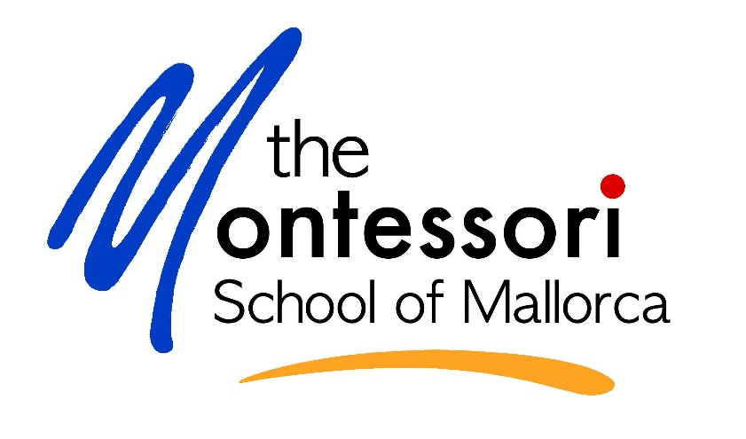

‘Montessori at Home’
Learning Journey Portfolio

The ‘Montessori at Home’ Learning Journey Portfolio is a record of your child’s work during this unusual time.

We are going to use the portfolios to assess your child and discuss her/his progress with you during our parent conferences.

How to put together the portfolio:

- If you have photos of your child working on the different areas (see below), please copy small-sized photos under the different headings.
If you do not have access to a printer or have no photos, you can add any work on paper that your child has produced in the past weeks.

- Also, if you have photos of your child cooking, gardening, making games or of any other work produced/or that your child was involved in, please add photos to the portfolio.

Feel free to add any additional work or comments that you wish to share at the back of the ‘Montessori-At-Home Learning Journey Portfolio!

Please hand in the Learning Journey Portfolio at the school’s office between May 18th -29th between 10h00 and 12h00. If you don’t have a printer, please send the portfolio to Maddy at casa@montessorimallorca.org.

We can of course return the portfolio to you at the end of the term if you wish so.
My learning experience at home
This is me and my family
(Please add a picture or a drawing)

This is my work space

This is where I see my teachers and friends online

I’m doing practical life and chores!

I’m curious about my senses.
Please try to include some of the higher numbers your child is working on.
Please try to include some operations if your child is working on them (adding, subtracting, multiplying, dividing)

Here I’m working on maths

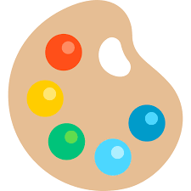

Arts, crafts, and culture!

Please try to include a photo of your child drawing or writing (holding a pencil).

Younger children, please try to include an example of your child mark-making (drawing, writing their name, writing letters, etc.)

Older children, please try to include an example of your child’s writing.

Older children, please try to include a photo of your child and a book they are able to read by themselves/with just a little support

Now I’m working on language

