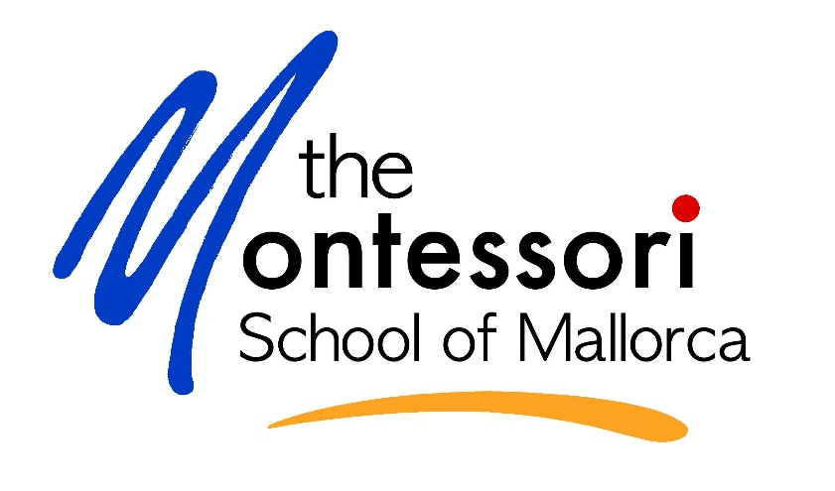

‘Montessori at Home’
Learning Journey Portfolio

The ‘Montessori at Home’ Learning Journey Portfolio is a record of your child’s work during this unusual time.

We are going to use the portfolios to assess your child and discuss her/his progress with you during our parent conferences. Please ensure that the work you submit has been produced independently by your child.

How to put together the portfolio:

- If you haven’ t done so yet, collect and organize samples of your child’s work during the lockdown.
- Look at what is required for your child’s age group (see ‘Work Samples’ below) and select their best work. If your child does not have anything to share, it could be that their group did not cover this area, just put a note so that we are aware.
- Place the required pieces of work in the order as shown in the table below. Please only use work that your child has already completed.
- It would be helpful if you could include a title and date on each sample, just like we did in the classroom.

Also, if you have photos of your child working, their personal work area, cooking, gardening, making games or of any other work produced/or that your child was involved in please copy small-sized photos and add to the portfolio.

Feel free to add any additional work or comments that you wish to share at the back of the ‘Montessori-At-Home Learning Journey Portfolio!

Please hand in the Learning Journey Portfolio at the school’s office between May 18th -29th between 10h00 and 12h00.

We can of course return the portfolio to you at the end of the term if you wish so.

My learning experience at home
This is me and my family
(Please add a picture or a drawing)

Work samples

Table of Contents | Lower Primary | Upper Primary
Language: Writing | - At least 2 pieces of your best non-fiction writing  Your daily journal, book reviews  - At least 2 pieces of your best Handwriting samples  Using the online resources  - At least 2 pieces of your best Writing samples  Using the online writing prompts  - At least 2 Follow-ups from grammar and word study  Include any of your best work from rhyming, syllabication, grammar | - At least 2 pieces of non-fiction writing  book review, film review, your writing journal, Mayan reports and other cultural writing  - At least 2 pieces of fictional writing  creative writing pieces, stories from the video clips  - At least 2 Follow-ups from our lesson  Include any of your best work from  positional language, adjectives, adverbs, fronted adverbials, types of punctuation mark, speech punctuation, relative clauses – depending on with language group you are in!
Language: Reading | - At least 2 examples of Reading comprehension  activities from online resources  - Read Every Day Journal | - At least 3 examples of Reading comprehension activities/Guided Reading Follow up Questions  - Spring and/or Summer Reading Journal
Spelling | - examples of spelling practice using the MMs Spelling Lists and or I can Read 100 Words | - examples of spelling practice using the Puzzle words or the spelling correction sheets
Mathematics / Geometry | - At least 2 examples of you using the four operations of Mathematics: Addition, Subtraction, Multiplication and Division (3 or 4 -digit equations)  - At least 2 examples of Math Facts practice using online support materials / games / finger charts  - Examples of Word Problems  - Knowledge of Geometric Solids / Geometric Cabinet  - Knowledge of Measurement / Perimeter / Area / Measuring Angles  - Knowledge of Roman Numerals / Numeration | - One Arithmetic Paper - Upper 11s only  - At least 2 examples of you using the Four Operations  Addition, Subtraction, Multiplication and division  - At least 2 examples of Math Facts  practice using online support materials or games  - Knowledge of Fractions, decimals and percentages (Groups M2, M3, M4 and M5)  - Examples of Word Problems  - Knowledge of Geometry  Shapes, translations, different types of lines  - Knowledge of Measurement  Perimeter, Area, Measuring Angles, real-life measuring
Cultural | - Paper Bag Plot Project -  Including characters / events, in order, with descriptions following instructions given on Project Rubric  - At least 2 examples of projects / follow-ups you have done with the themes followed in our online classes such as: endangered animals, lifecycles of plants and animals, scientific method (experiments), geography, Earth Day, etc. | - Personal Project – written in the correct forma  Including photographs of any props that you have or have made.  - At least 3 examples to demonstrate knowledge of Science, History and Geography  Examples of mini-projects / follow-up work – including a variety of written work and photographs/drawings - from your Cultural Folder choices. Such as: Clouds, classification of animals and plants, rivers, rocks, minerals, fossils, volcanoes, continents, The Maya Civilisation, Science Projects etc.

Spanish: Writing | - At least 2 pieces of your best descriptive text  Description of: School, home, bedroom.  - At least 2 pieces of your best Instructional text  Cooking Recipe, steps to wash your hands correctly, steps to do a class with the computer  - At least 2 pieces of your best Narrative text  Fictional Story | - At least 2 pieces of your best descriptive text  Description of school, home, bedroom, place of your choice.  - At least 2 pieces of your best Instructional text  Cooking Recipe, steps to wash your hands correctly, steps to do a class with the computer  - At least 2 pieces of your best Narrative text  Fictional Story
Spanish: Reading | - 2 examples of Reading comprehension activities from the book | - 3 examples of Reading comprehension activities from the book
Spanish: Spelling | - List of 20 words with errors  Choose the correct option | - List of 40 words with errors  Choose the correct option
Spanish: Writing and Speaking  (Non-Native) | - Oral test of contents to determine language progress will carried out by Dani  - Write some short sentences  About yourself, family, favourite things (writing frame provided) | - Oral test of contents to determine language progress will carried out by Dani  - Write some short sentences  About yourself, family, favourite things (writing frame provided)
Spanish: Spelling  (Non-Native) | - List of 10 words with errors  Choose the correct option | - List of 15 words with errors  Choose the correct option
Catalan: Writing  (Native speakers only) | - At least 2 pieces of your best descriptive text  Personal description, description of father or mother, description of family pet (add photographs or drawings)  - At least 2 pieces of your best Instructional text  Friends, teachers and family  - At least 2 pieces of your best Narrative text  Fictional Story | - At least 2 pieces of your best descriptive text  Personal description, description of father or mother, description of family pet (add photographs or drawings)  - At least 2 pieces of your best Instructional text  Friends, teachers and family  - At least 2 pieces of your best Narrative text  Fictional Story
Catalan: Reading  (Native speakers only) | - 2 examples of Reading comprehension activities from the book | - 3 examples of Reading comprehension activities from the book
Catalan: Spelling  (Native speakers only | - List 20 words with errors  children choose the correct option | - List 40 words with errors  children choose the correct option
German  (if you attended) | - Please include any examples of work from your German classes that you would like to share with us | - Please include any examples of work from your German classes that you would like to share with us
Practical Life/Art/Music  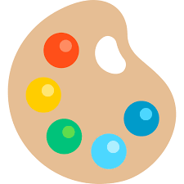 | - Please include any examples of work or photographs from your German classes that you would like to share with us | - Please include any examples of work or photographs from your German classes that you would like to share with us

